**Python Loops**

Python has two primitive loop commands:

* while loops
* for loops

The while Loop

* With the while loop we can execute a set of statements as long as a condition is true.

Example:

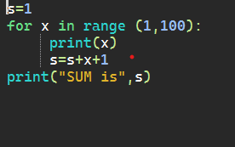

Python For Loops

A for loop is used for iterating over a sequence (that is either a list, a tuple, a dictionary, a set, or a string).

This is less like the for keyword in other programming languages, and works more like an iterator method as found in other object-orientated programming languages.

With the for loop we can execute a set of statements, once for each item in a list, tuple, set etc.

Example:

